- Create one VPC, with 1 public subnet and 1 private subnet.

🔹 Step 1: Create VPC
- Open AWS Management Console
- Search → VPC
- Click Create VPC

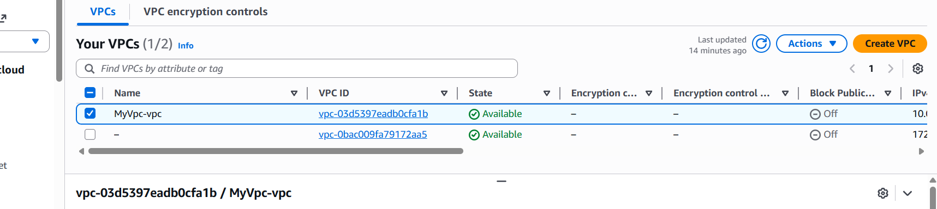

🔹 Step 2: Create Subnets
🟢 Public Subnet
- Go to Subnets → Create subnet
- Select your VPC
- Enter:
  - Name → Public-Subnet
  - CIDR → 10.0.1.0/24

Once done with the naming the subnet and CRDI
Subnet - → Public-Subnet (name)
CRDI - 10.0.1.0/24
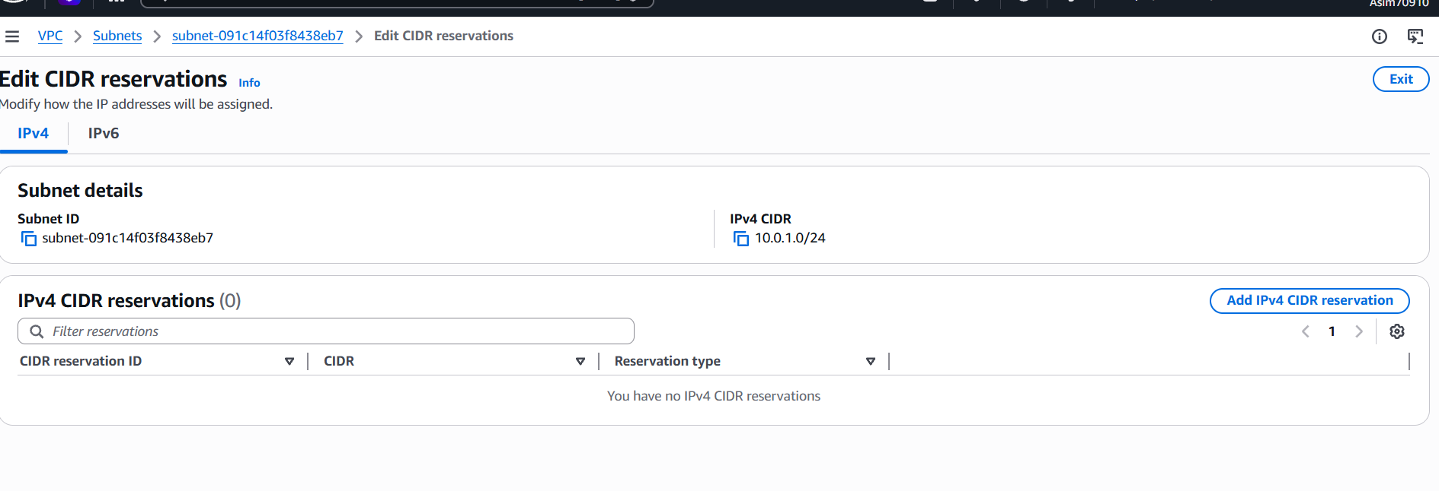

You can see your created subnet name in subnet list

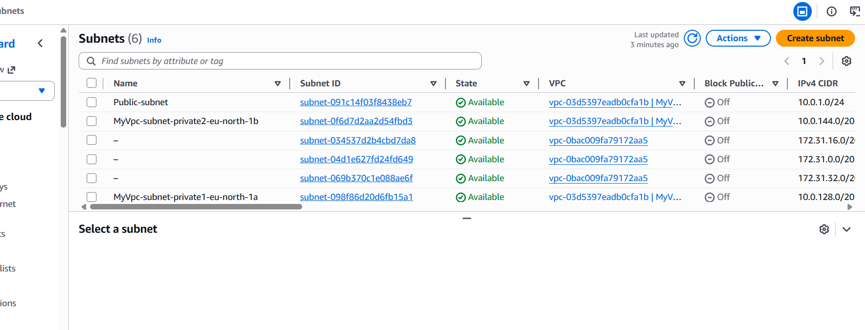

🔴 Private Subnet
- Click Create subnet again
- Enter:
  - Name → Private-Subnet
  - CIDR → 10.0.2.0/24
👉 Why separate?
- Public → for web servers
- Private → for databases / secure apps

Once created your private subnet you can see your subnet name is the list
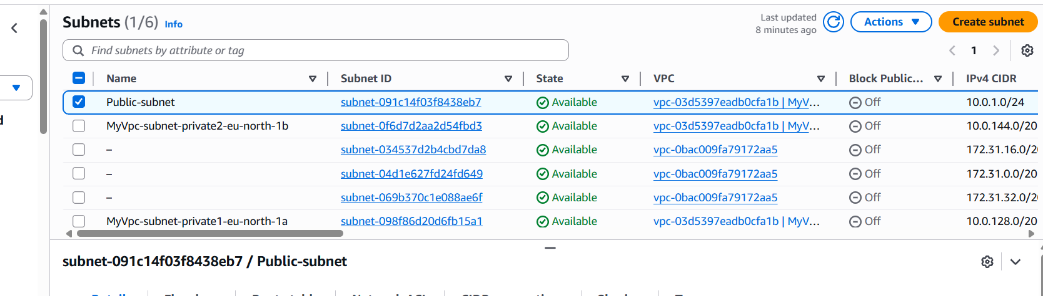

🔹 Step 3: Create Internet Gateway (IGW)
- Go to Internet Gateways
- Click Create
  - Name → MyIGW
- Click Attach to VPC
  - Select MyVPC
👉 Why?
Without IGW, your VPC cannot access the internet.
Once you created your gate way, as I have created my igw ( my gate way name) shown below

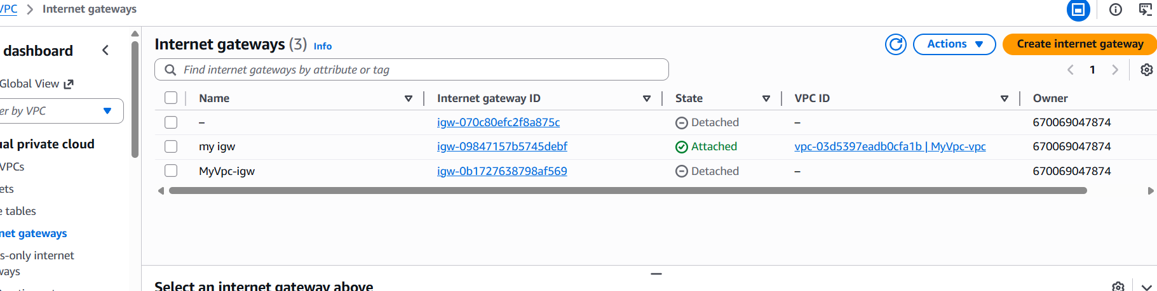

🔹 Step 4: Create Public Route Table
- Go to Route Tables → Create
  - Name → Public-RT
  - Select VPC
- Click Edit Routes → Add route
  - Destination → 0.0.0.0/0
  - Target → Internet Gateway (MyIGW)
👉 Why?
0.0.0.0/0 means “send all internet traffic outside”
Once you created route table you can see your name of the route table which you have created such as shown below my “public – rt”
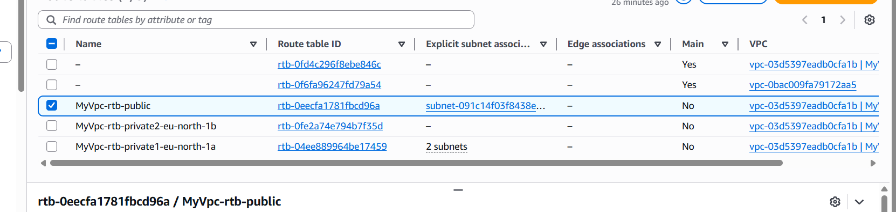

🔹 Step 5: Attach Route Table to Public Subnet
- In Public-RT
- Go to Subnet Associations
- Click Edit
- Select → Public-Subnet
👉 Now this subnet becomes public

Selected public rt
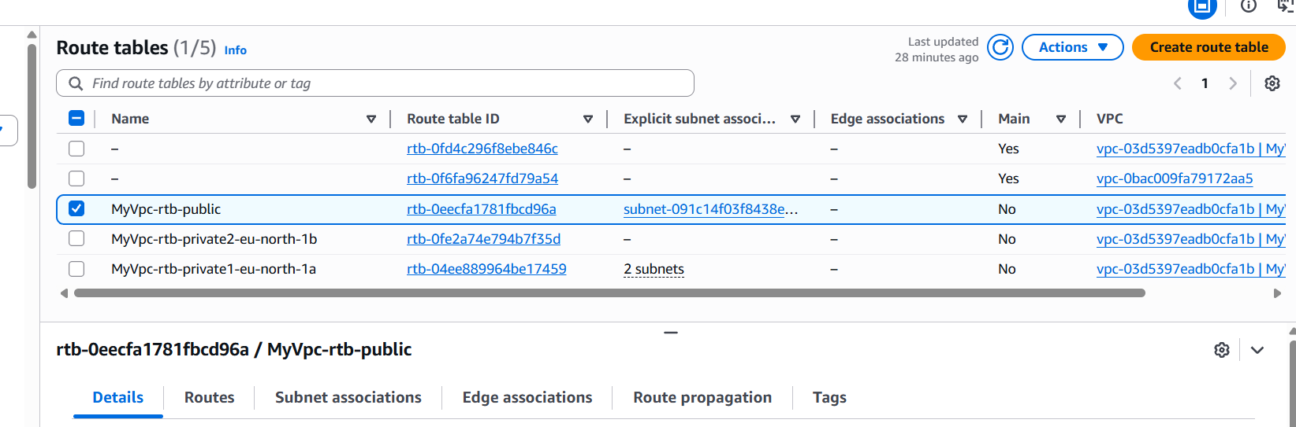

- Went to subnet associations and clicked on edit subnet association and selected public subnet
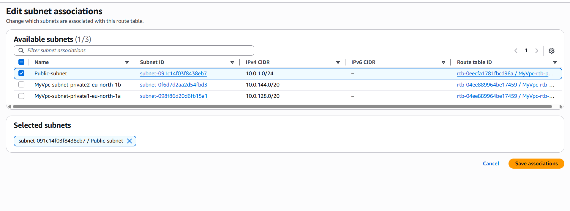

🔹 Step 6: Enable Public IP for Public Subnet
- Go to Subnets
- Select Public-Subnet
- Click Edit subnet settings
- Enable:
  - ✅ Auto-assign public IPv4
- 👉 Why?
Instances need a public IP to access the internet.
Enabled the ipv4 address
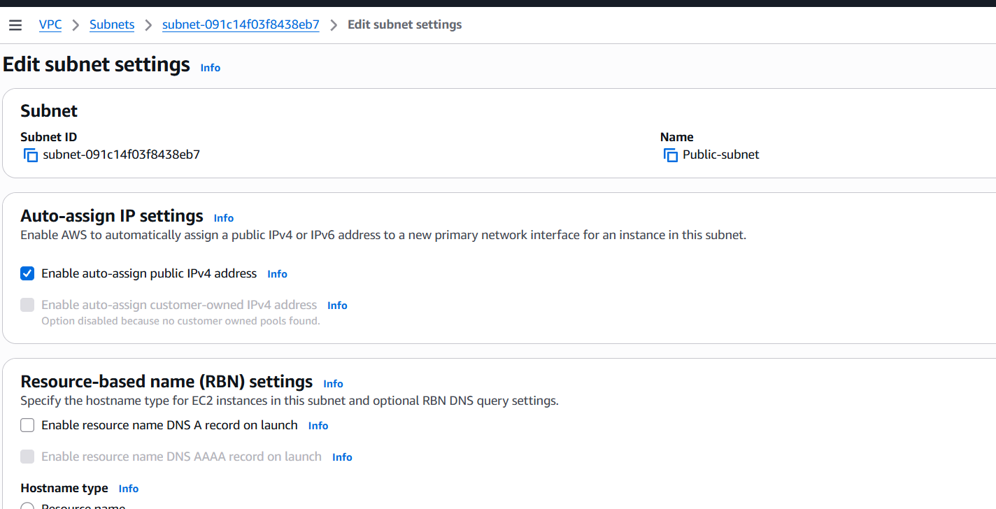

VPC (10.0.0.0/16)
│
├── Public Subnet (10.0.1.0/24)
│ ├── Route → IGW
│ ├── Public IP enabled
│ └── Used for Web Servers
│
└── Private Subnet (10.0.2.0/24)
├── No direct internet
└── Used for DB / backend
- Enable VPC peering for cross-account (you can collaborate with your friend to do this task).
🔹 Step 1: Create Peering (from Stockholm)
- Open AWS Management Console
- Make sure region = Stockholm (eu-north-1)
- Go to VPC → Peering Connections
- Click Create
Fill:
- Requester → Stockholm VPC
- Accepter:
  - Select → Another Region
  - Region → Mumbai (ap-south-1)
  - VPC → your Mumbai VPC

Mistakes I did
- I got confused here as it mentioned request Stockholm vpc to accepter - ( Ex Mumbai region server )

    - I did not know acceptor means the other region which needs to accept, for that I need to go to Mumbai server region and create VPC and same subnet, Gate way and rooting table.
2. Then come back to Europe server region where I actually created the first VPC and need to fill the peering section
3. I need to fill my VPC ( random name) and select my VPC and check my CRDI number ex -
4. I need to go select other region and select the region name such as Mumbai, I did a mistake added my Mumbai server ID in place of VPN ID then check with Chat Gpt and I need to add my VPN ID of Mumbai server. I was able to successfully peer from Europe server region
Below is the image what all you need till fill before peering
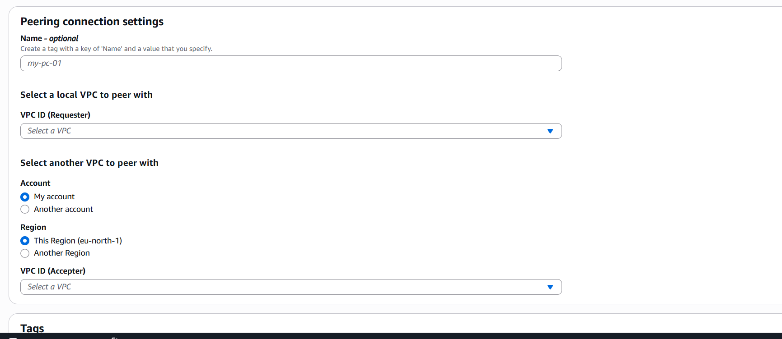

- Then I went to Mumbai region and above actions tab I have check for the request option and accepted the request as you can see in the below image
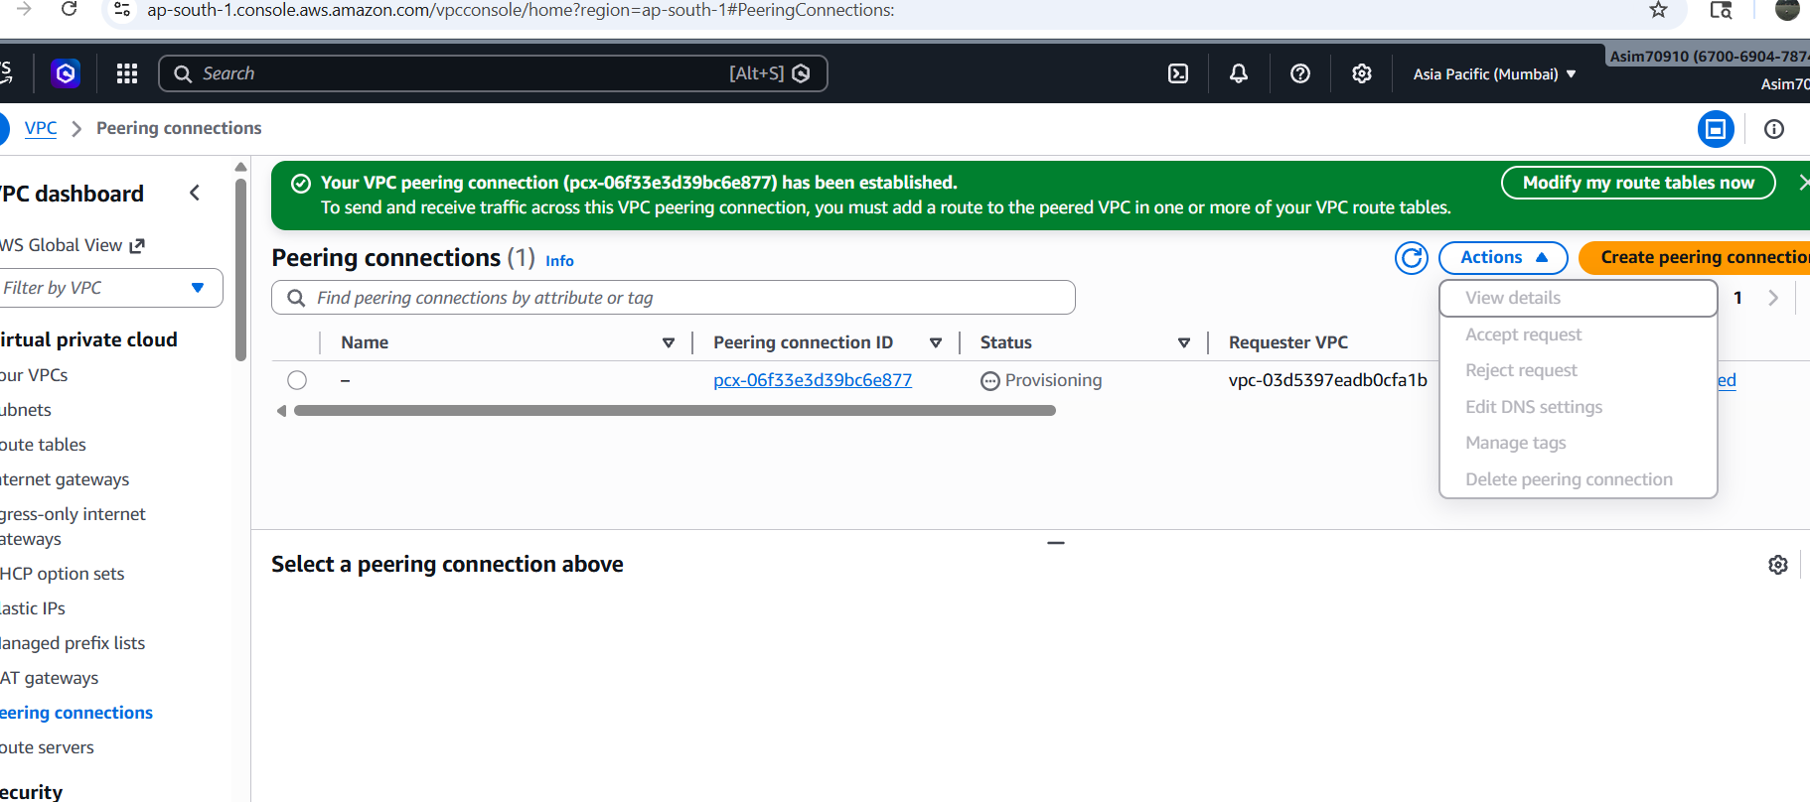

- Another I got to know do not proceed ahead with next step unless the status is active as its still provisioning in the above image. If it still shows provisioning check the action tab and if not refresh the tab it will show provisioning
From chat Gpt Next step after 6

🔹 Step 1: Add Route in Stockholm VPC
- Switch region → Stockholm (eu-north-1)
- Go to Route Tables
- Select the route table used by your subnet
(usually “main” if you didn’t create custom)
- Click Edit routes → Add route
- Add:

- I was confused which route table I have to select, then I checked the route table used by my subnet and did the editing in route as shown

( Select the route table used by your subnet
(usually “main” if you didn’t create custom)
Click Edit routes → Add route )

- I have edited the route sitting and added
(Destination → 172.31.0.0/16 Target → Peering Connection (pcx-06f33e3d39bc6e877)

- Another mistake I did was did not create VPC for other region and no subnet, gate way routing table
- Also I did not create an instance
I did create an instance but did not allow ssh in order to connect to Git bash, as I need SSH to connect to git bash
Another mistake I did was copied public ip address instead of private Ip address

Big mistake – another big mistake was I should I have selected default VPN in second region Mumbai I need to do again another instance and also had wrong CRDI
number in the edit port and after making the changes with CRDI in both Eu and mumbia it was finally launch
